Copyright for test papers and marking guides remains with *West Australian Test Papers.*

Test papers may only be reproduced within the purchasing school according to the advertised Conditions of Sale.

Test papers should be withdrawn after use and stored securely in the school until Friday 5th July 2019.



**SEMESTER TWO**

**MATHEMATICS**

**METHODS**

**UNIT 1**

**2019**

**SOLUTIONS**

**Calculator−free Solutions**

1. (a) Since *x* = 1 then 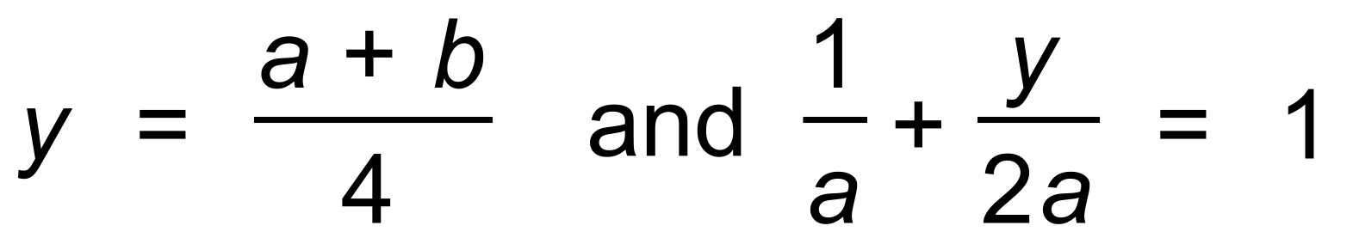 ✓

∴ 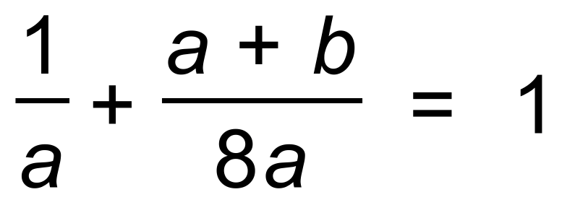 ✓

∴  ✓

(b) 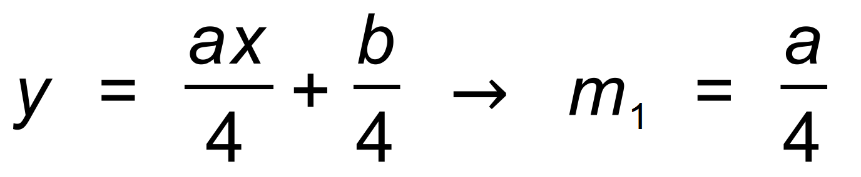 ✓

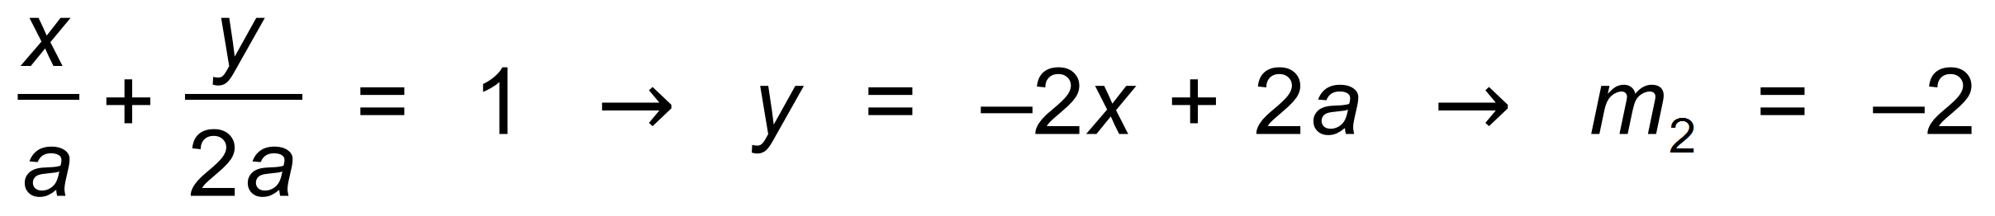 ✓

Since 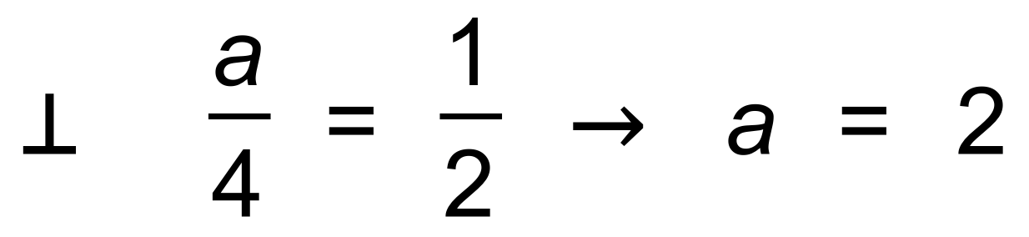 ✓

and *b* = 14 − 8 = 6 ✓ [7]

2. (a) 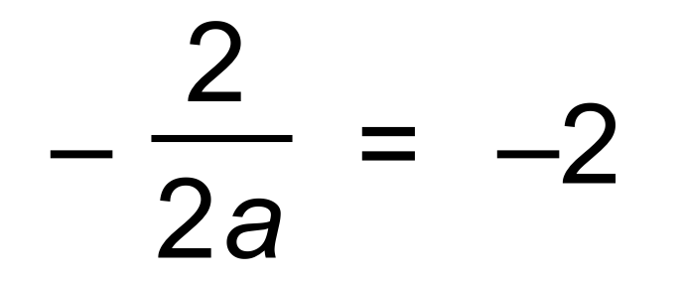 ✓

∴ 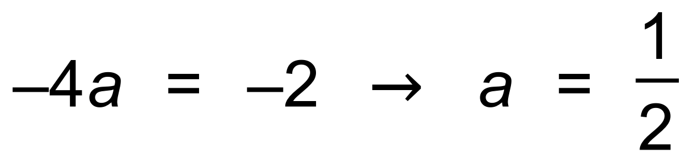 ✓

(b) 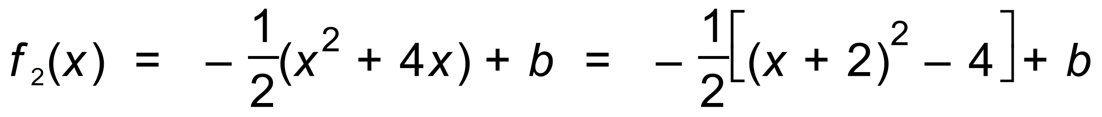 ✓

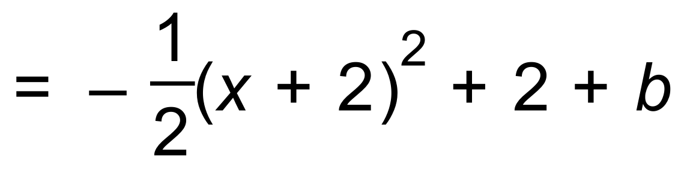 ✓

(c) Translation of *c* up 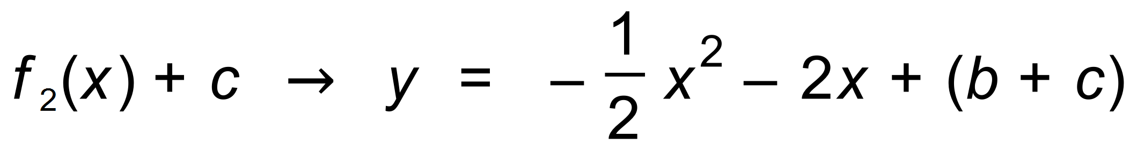 ✓

Since tangential, *b*2 − 4*ac* = 0

∴ 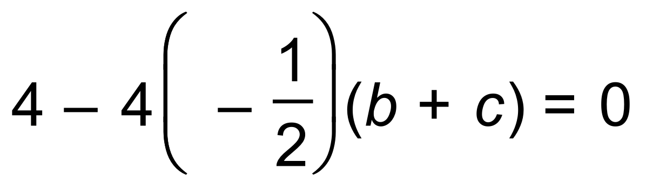 ✓

∴ 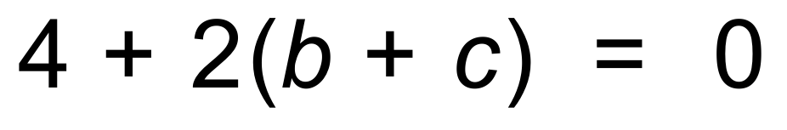 ✓

∴  ✓ [8]

3. (a) 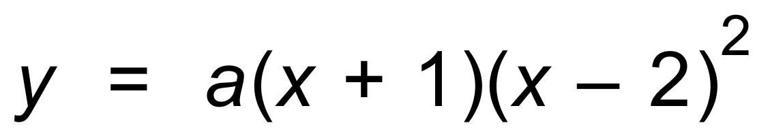 ✓

∴ 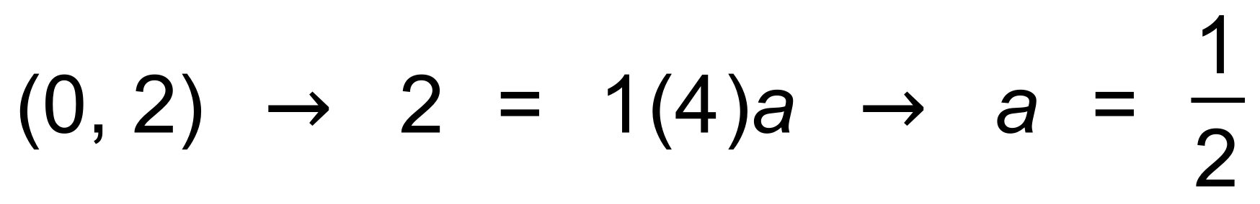

∴ 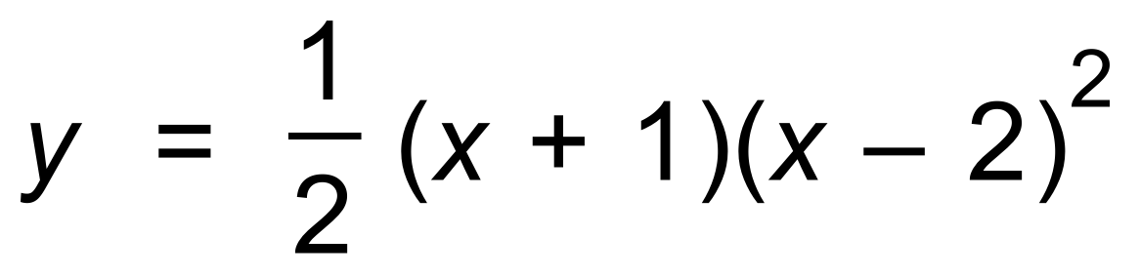 ✓

(b) 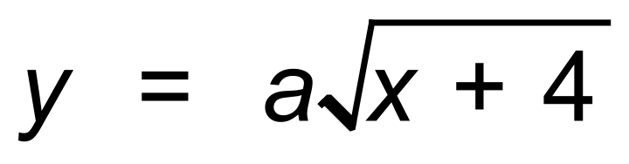 ✓

∴ 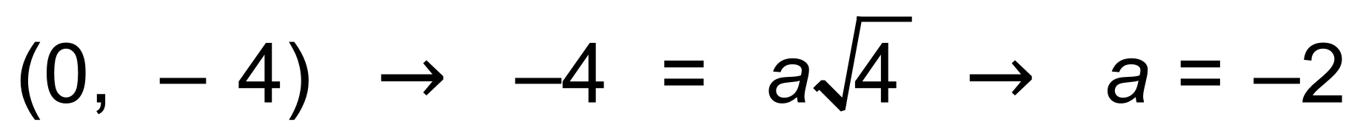 ✓

∴ 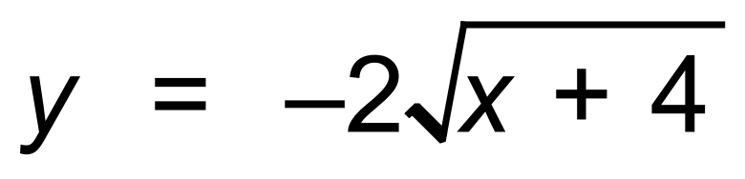 [4]

4. (a)  ✓

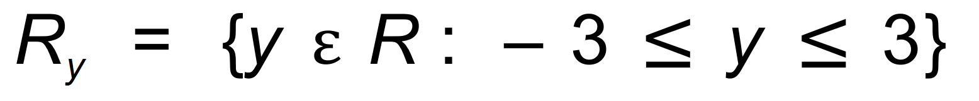 ✓

(b) 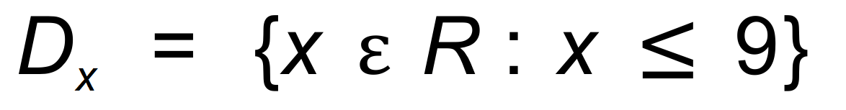 ✓

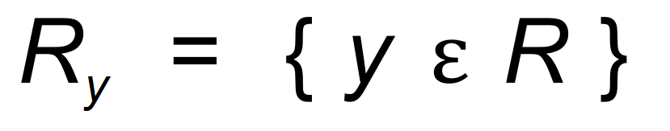 ✓

(c) There is a one to many mapping or vertical line test fails ✓ [5]

5. (a) (i) 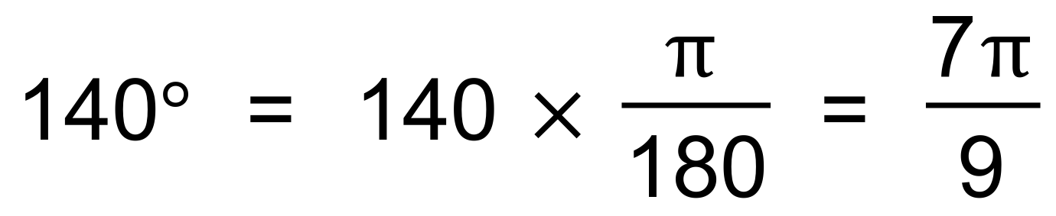 ✓

(ii) 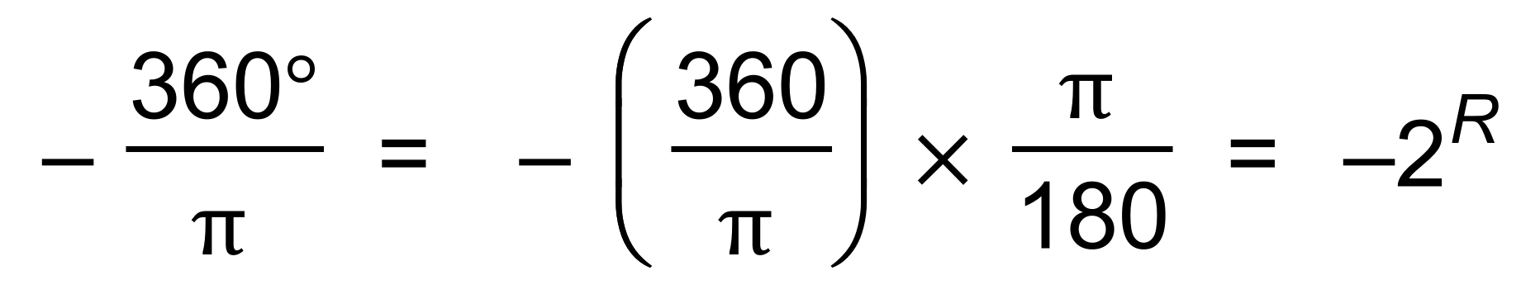 ✓

(b) (i) 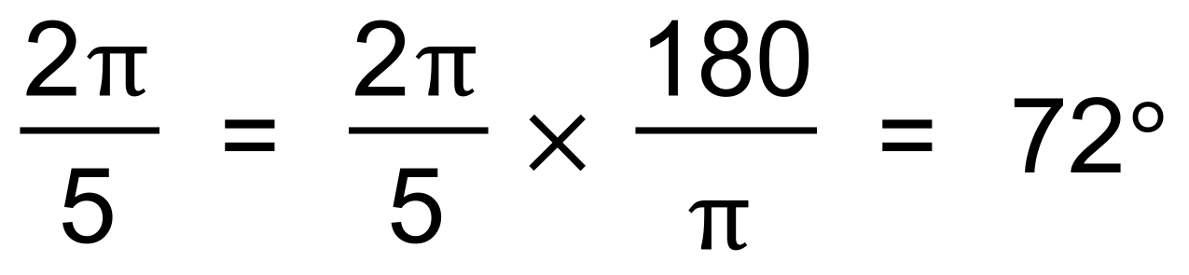 ✓

(ii) 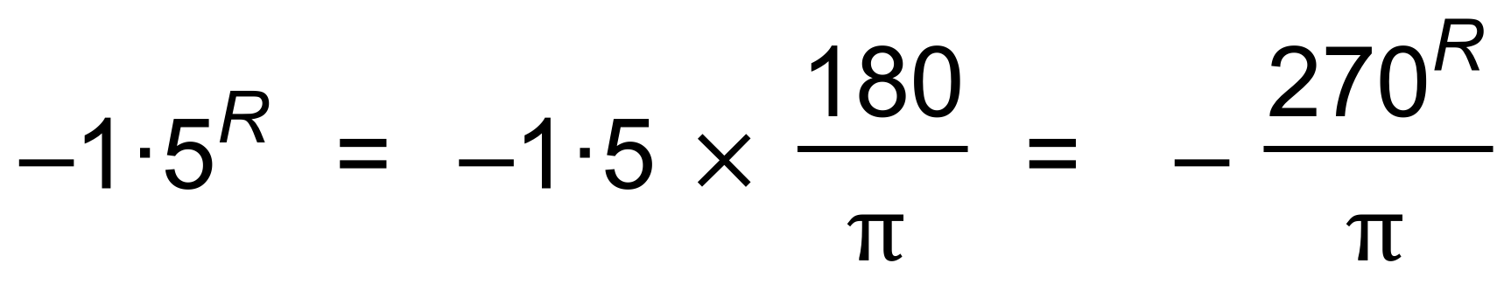 ✓

(c) 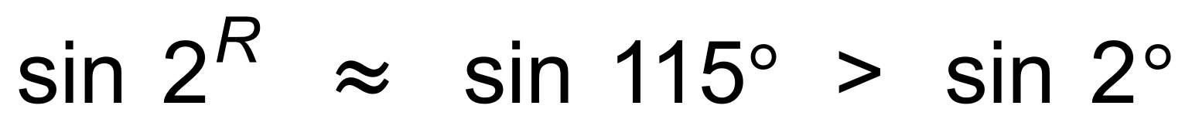 ✓

since it has a higher y value in the Unit circle. ✓ [6]

6. (a) 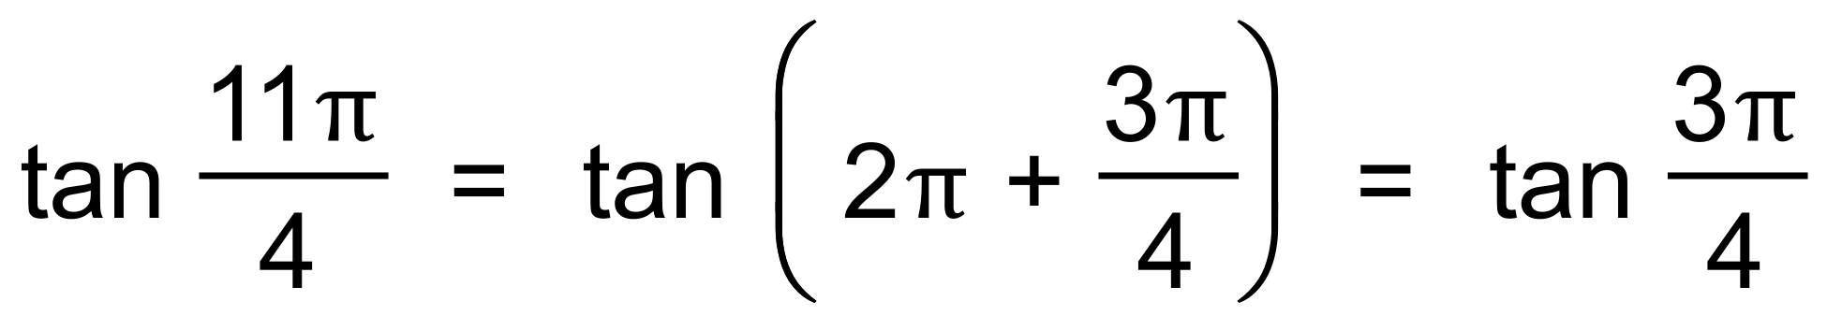 ✓

= −1 ✓

(b) 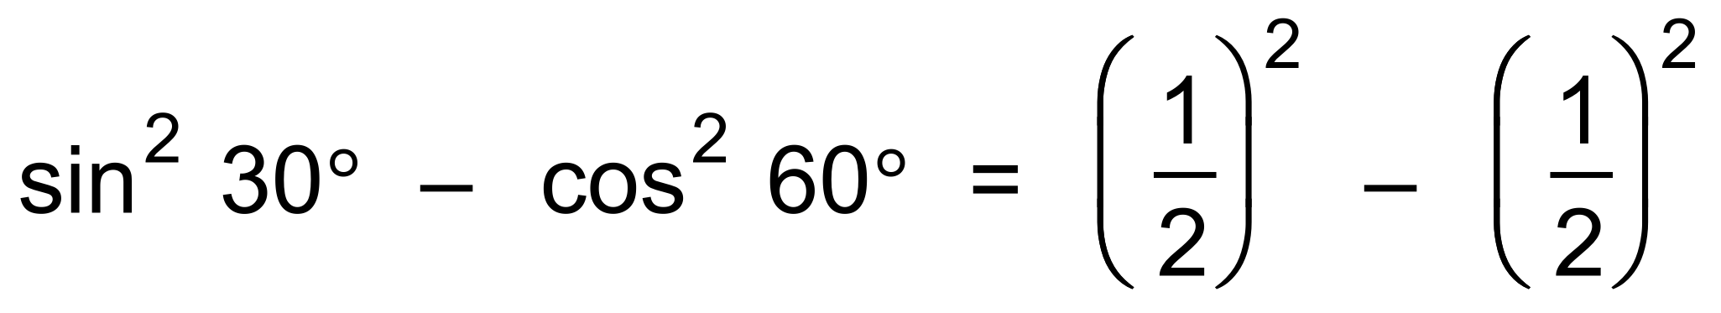 ✓

= 0 ✓

(c) 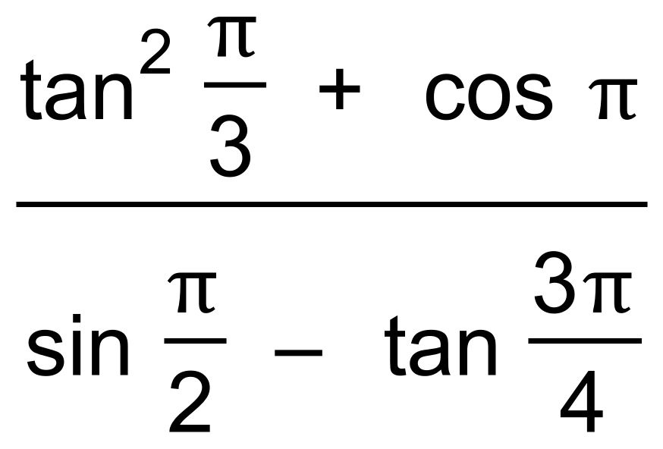 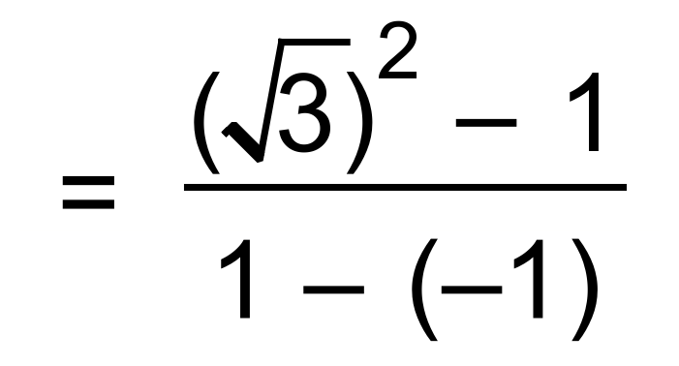 ✓✓

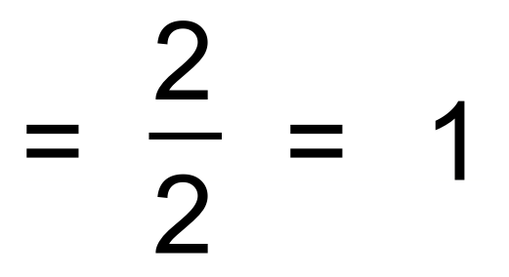 ✓ [7]

7. (a) a = −1 ✓

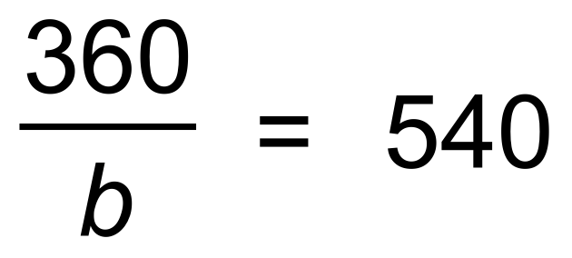 ✓

∴ 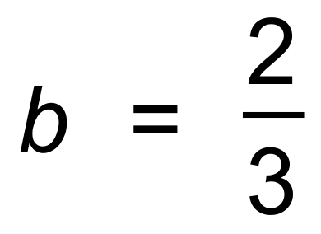 ✓

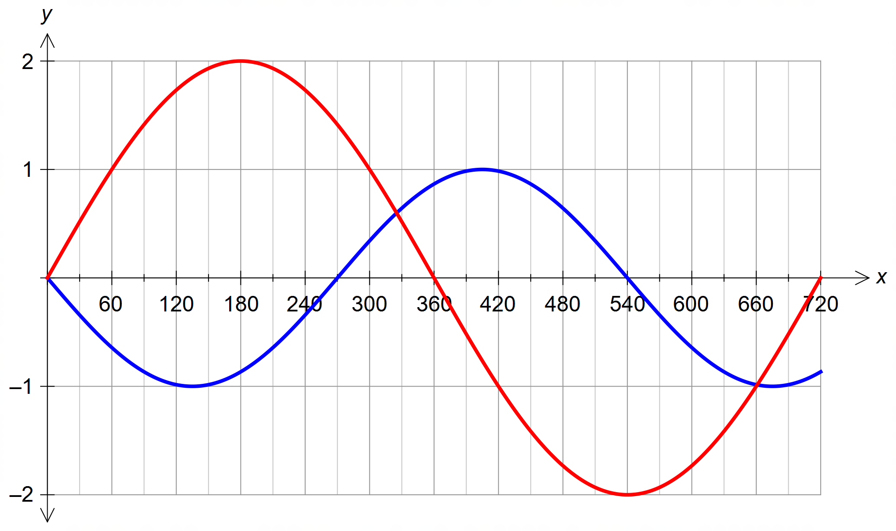 (b)

✓✓

(c) 0°, 330°, 660° ✓✓✓ [8]

8. (a) 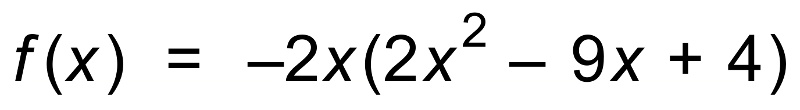 ✓

∴ 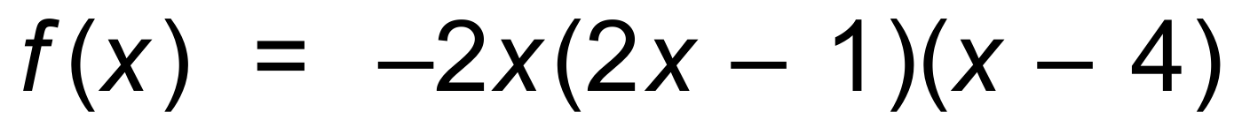 ✓

(b) (i) 

∴ 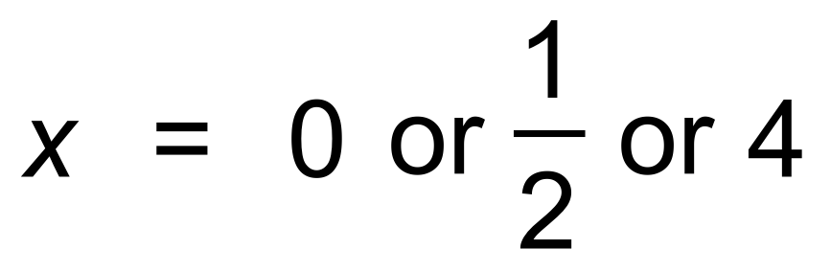 ✓

(ii) 

∴ 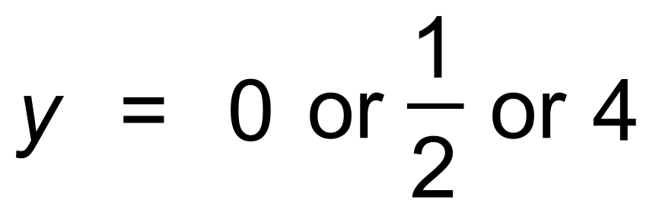 ✓✓ [5]

**Calculator−Assumed Solutions**

9. (a) n = 5 ✓

(b) 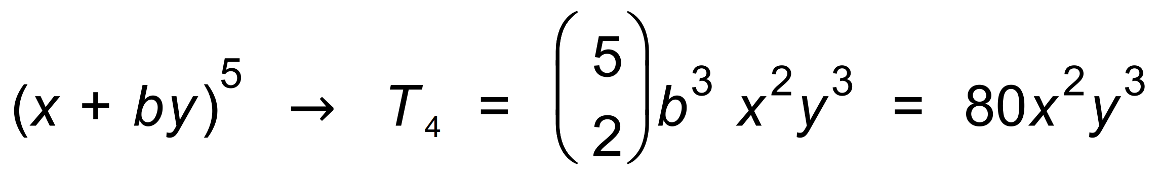 ✓

∴ 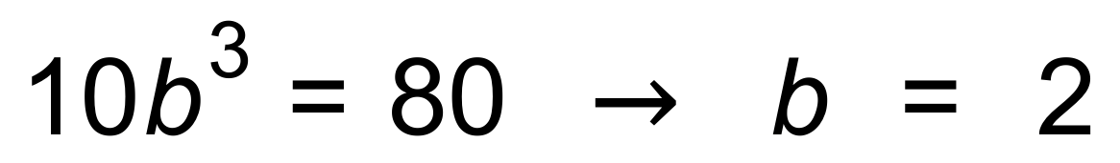 ✓

(c) 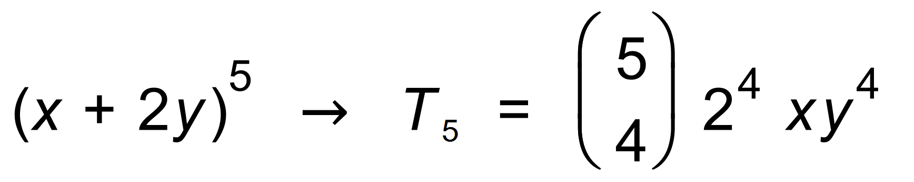 ✓

∴ 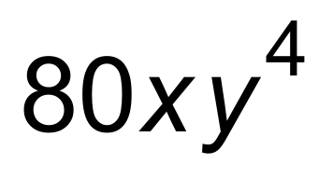 ✓ [5]

10. (a) (i) 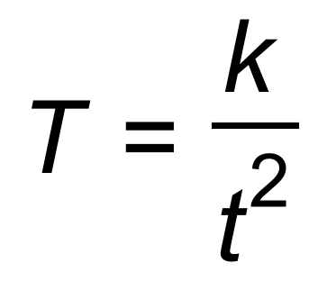 ✓

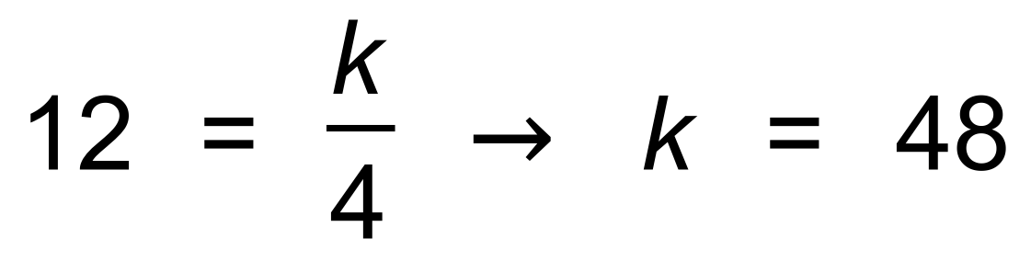 ✓

(ii) 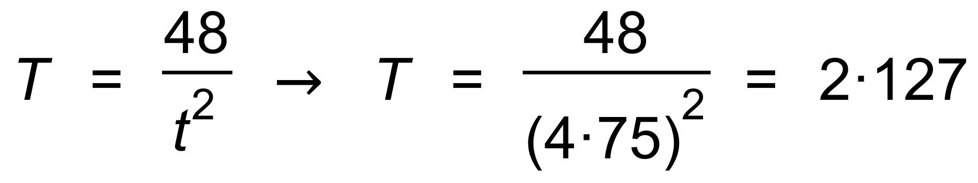  ✓

∴ Temperature is 2°C ✓

(b) D ✓ [5]

11. (a) 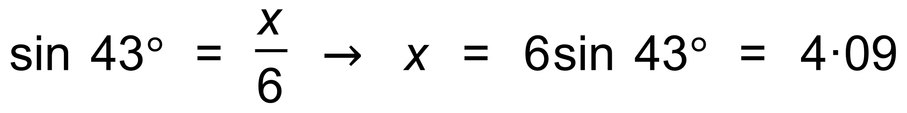 ✓

∴ 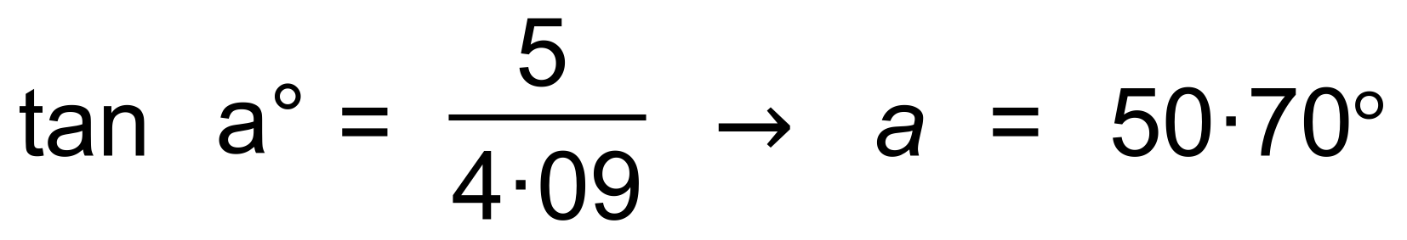 ✓

(b) 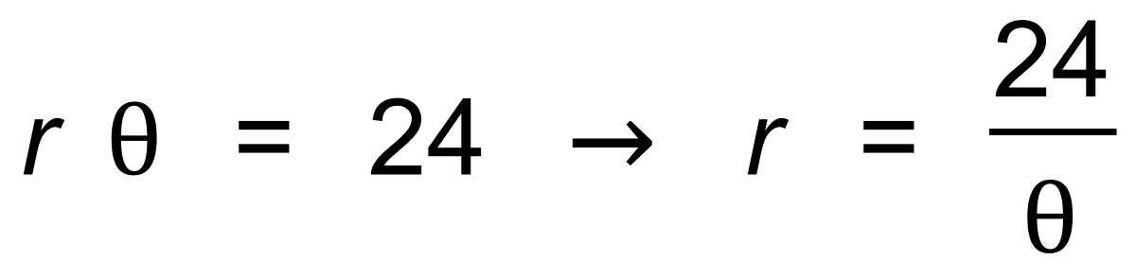 ✓

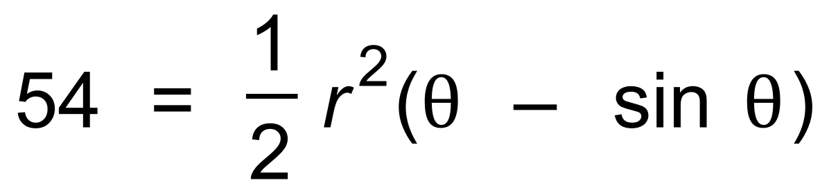 ✓

∴ 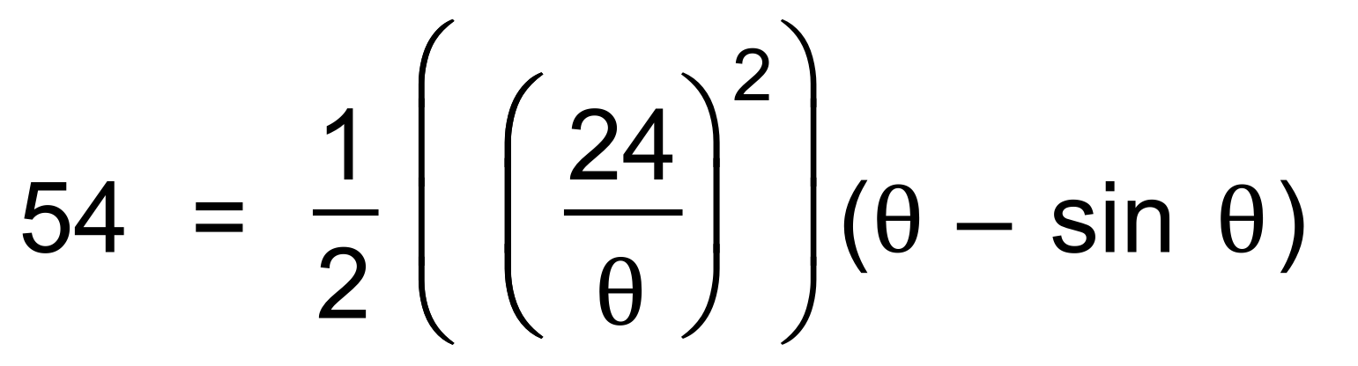 ✓

∴ θ = 1.211 ✓

∴ r = 19.8 cm ✓ [7]

12. (a) 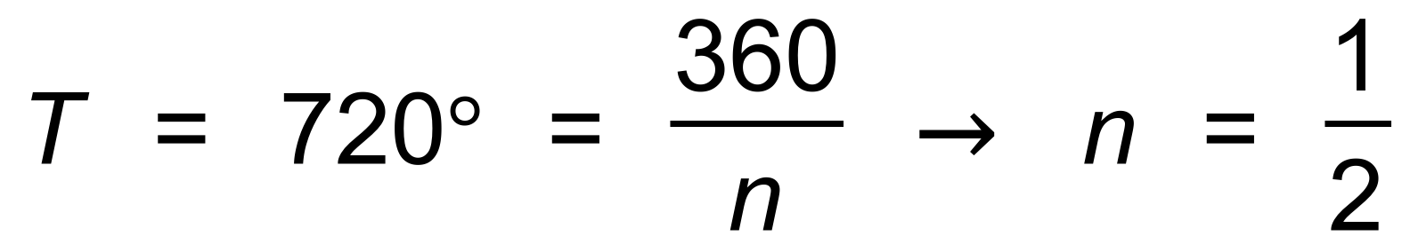 ✓

∴ 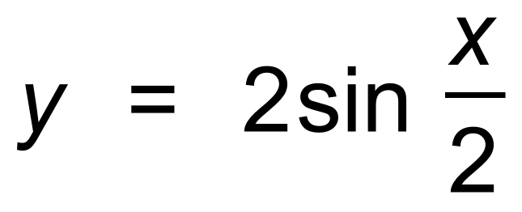 ✓

(b)  ✓

∴ 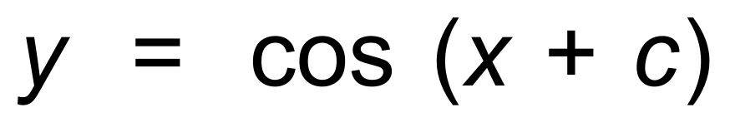 ✓

 ✓

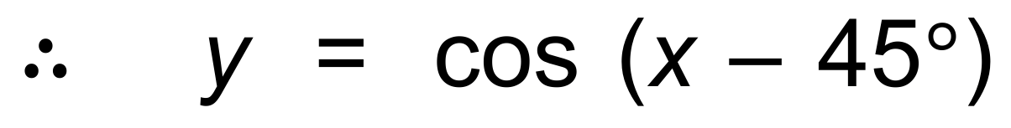

(c) 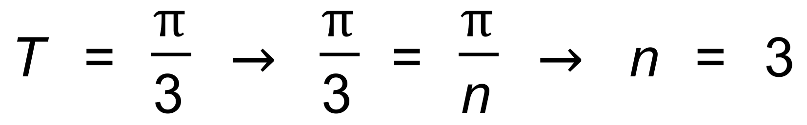 ✓

∴ 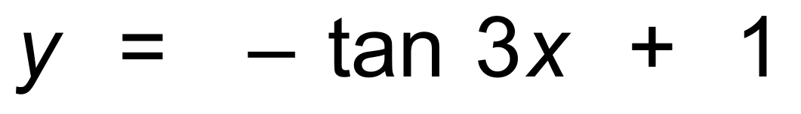 ✓✓ [8]

13. (a) 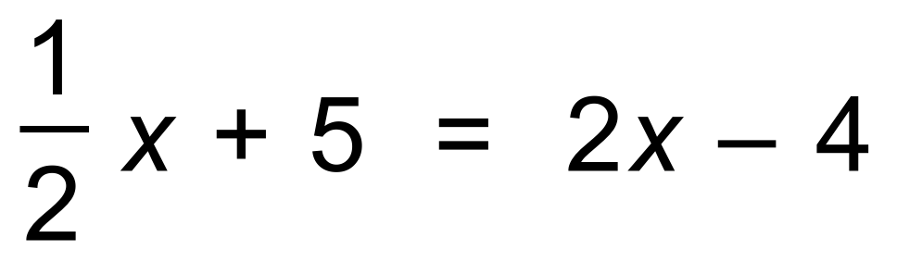 ✓

∴  ✓

∴ A(6, 8) ✓

(b) 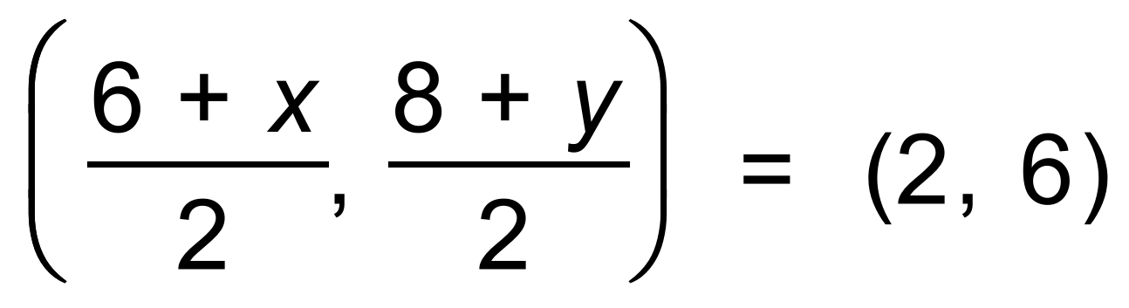 ✓

∴ B(−2, 4) ✓

(c) 

∴ (−2, 4) → *c* = 3 → 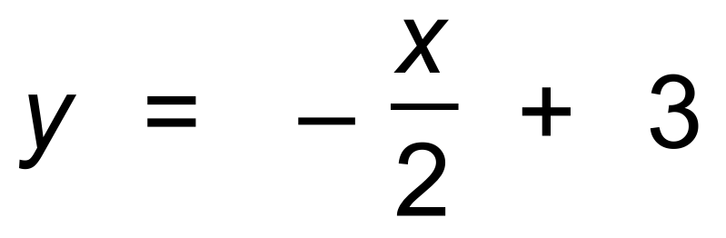 ✓

Hence 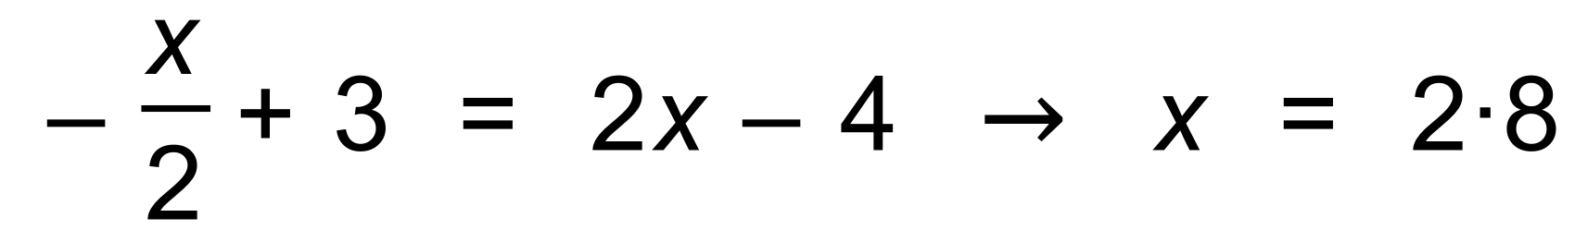 ✓

∴ C(2.8, 1.6) ✓ [8]

14. (a) (i)  ✓

= 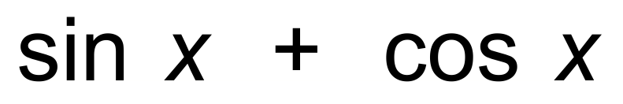 ✓

(ii)  ✓

= 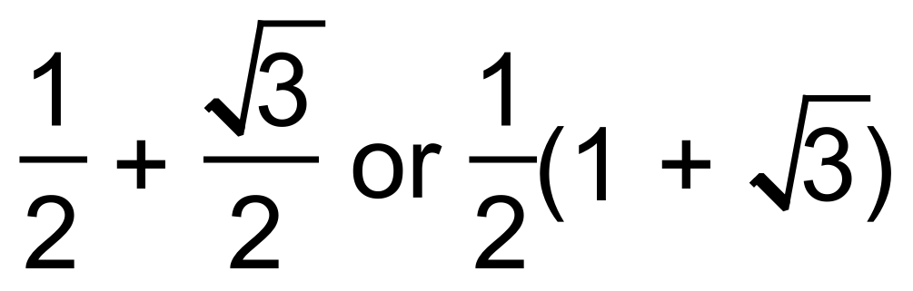 ✓

(b) 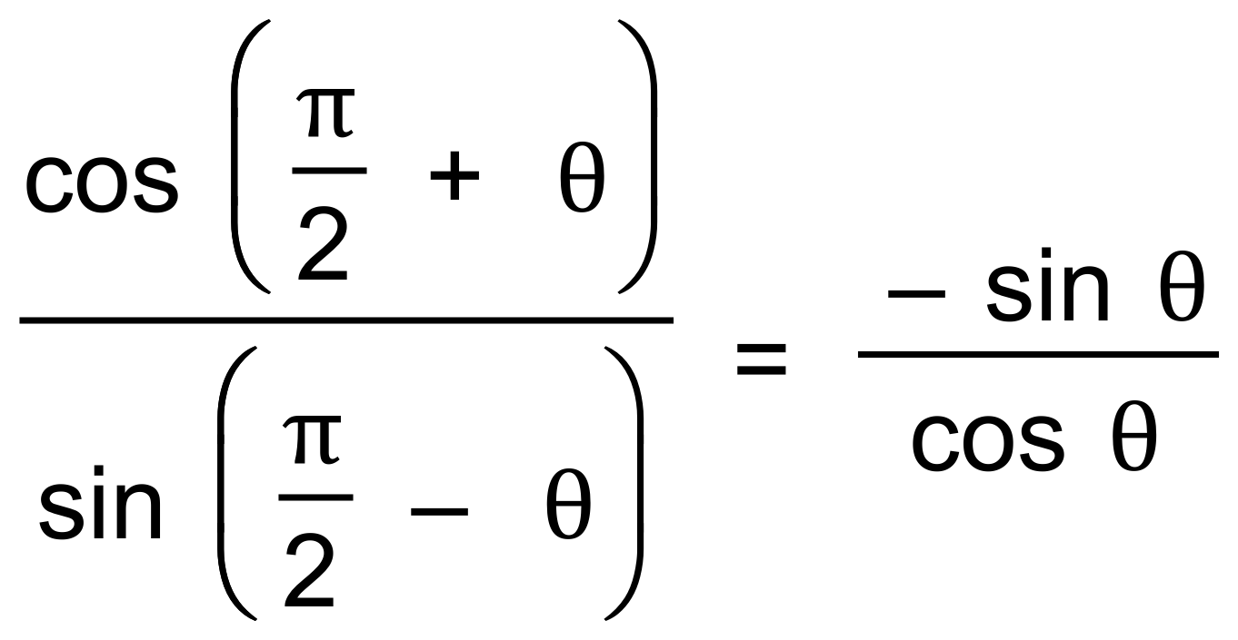 ✓

= 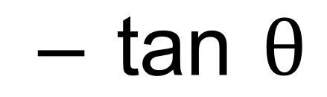 ✓ [6]

15. (a) It starts in section B. ✓

In section B, *h*(0) = 0 which is the initial height. ✓

(b) Section A = Section B when

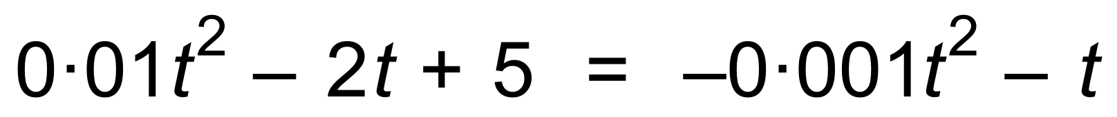 ✓

∴ *t* = 5.3 seconds ✓

(c) Occurs when Section A has its minimum ✓

∴ *h* = 95 m ✓

(d) Coaster back to height of zero when Section A = 0

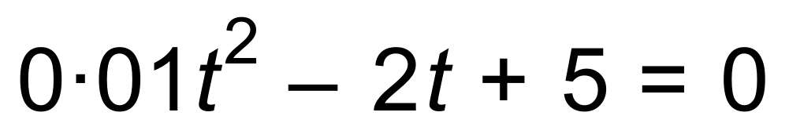 ✓

∴ *t* = 197 seconds ✓ [8]

16. (a) 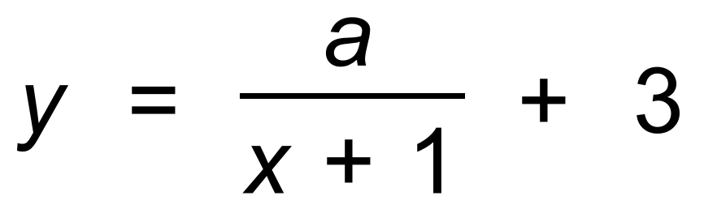 ✓✓

∴ (0, 1) 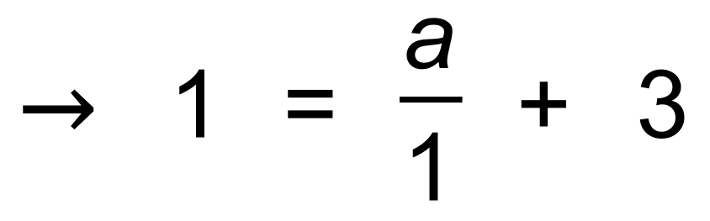 ✓

∴ 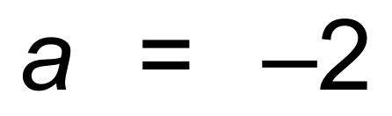 ✓

(b)

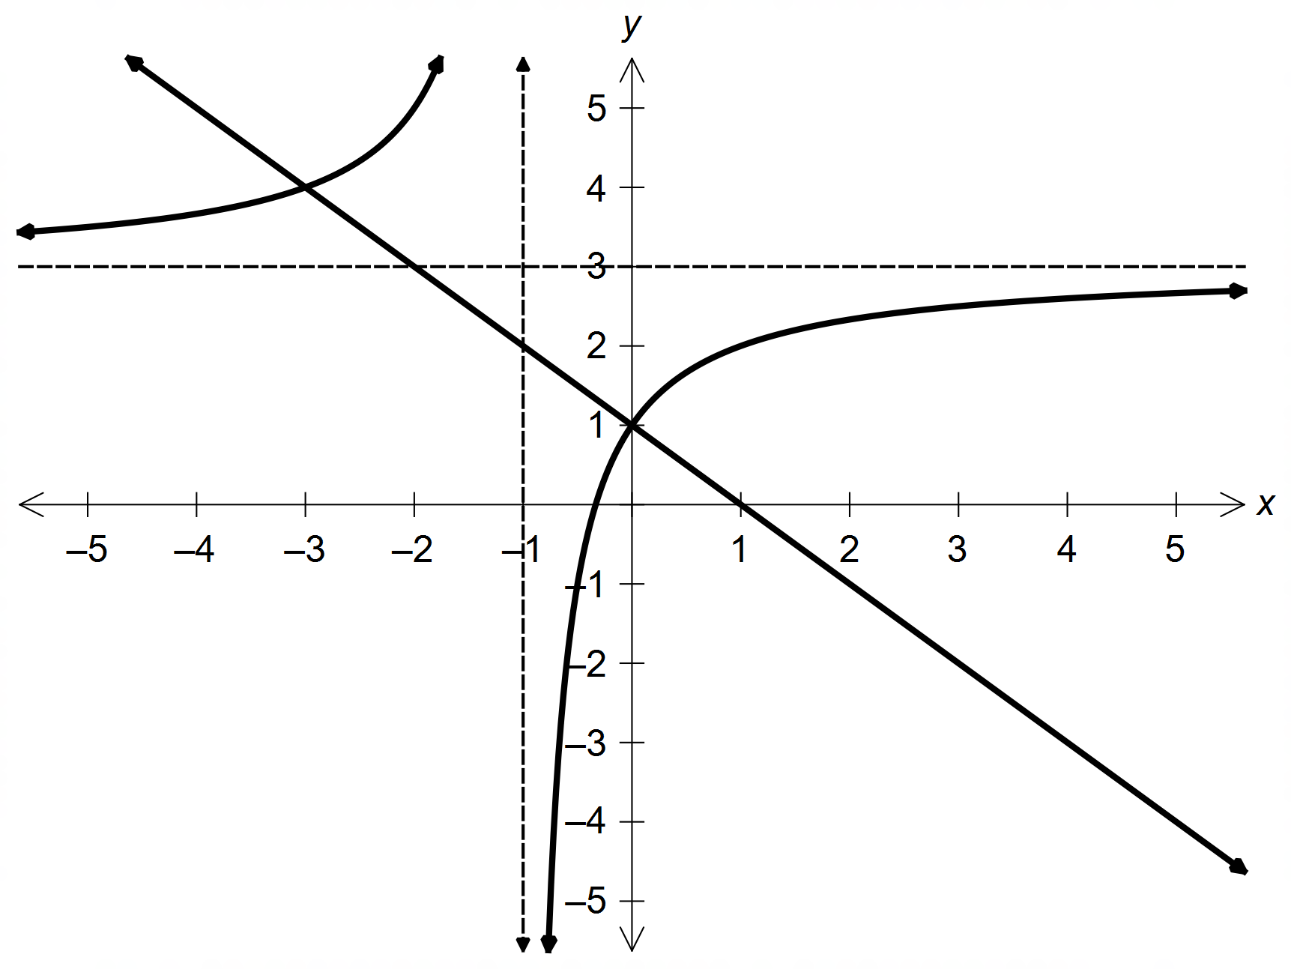

✓✓ [6]

17. (a) (i) 8.6 m ✓

(ii) *t* = 18 → 6 pm ✓

(b) 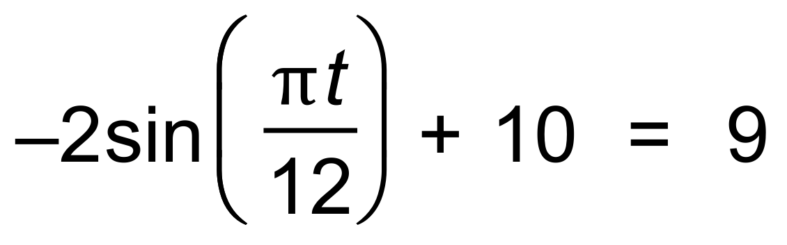 ✓

∴ *t* = 2 and *t* = 10 ✓

Hence between 2 am and 10 am. ✓ [5]

18. (a) *b* = 6

*f* = 10 ✓

(b) *b* + *c* = *f* ✓

(c) 13 ✓

(d) 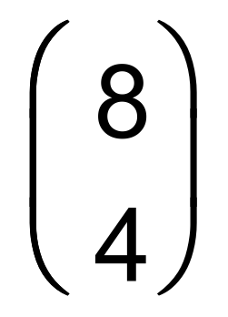 ✓

(e) 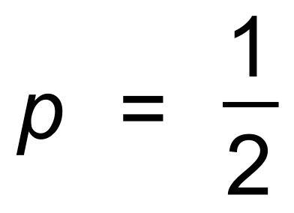 ✓✓ [6]

19. (a) (i) 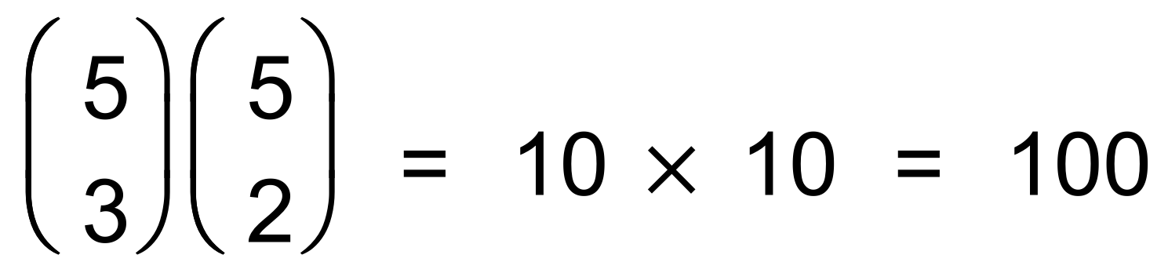 ✓✓

(ii) 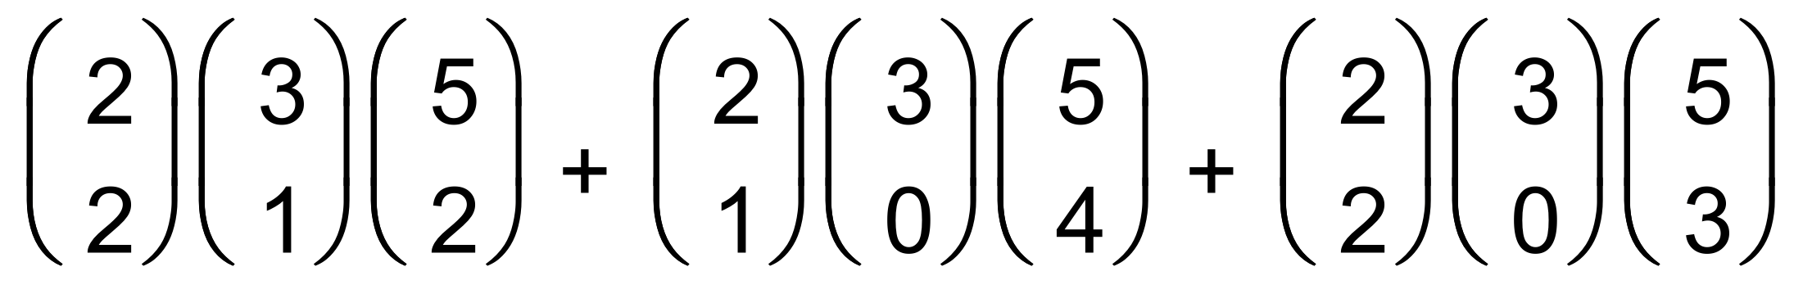 ✓

= 30 + 10 + 10 = 50 ✓

(b) How many different selections containing four blue pens ✓

and a black pen are possible? ✓

(c) (i) 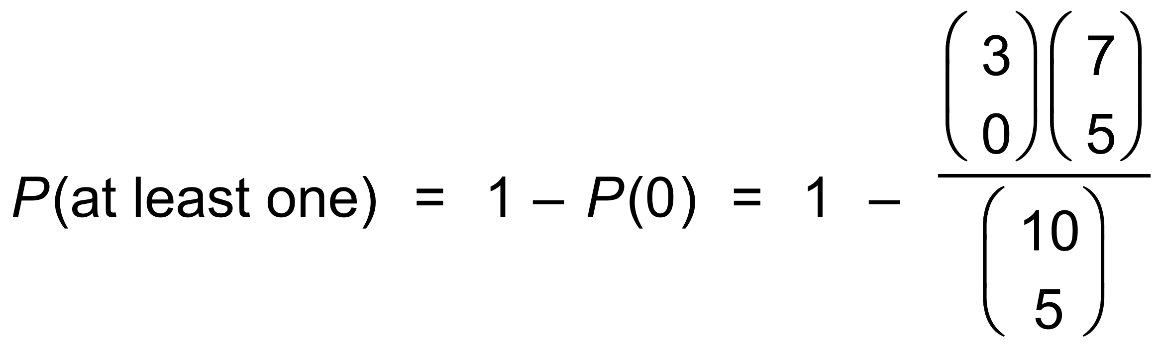 ✓

= 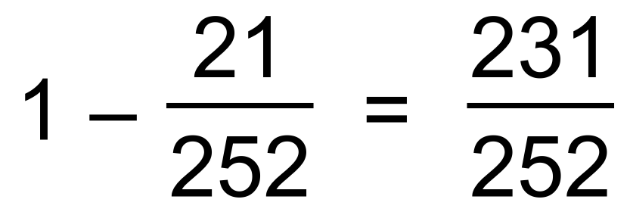 ✓

(ii) *P*(at most two red | at least one red)

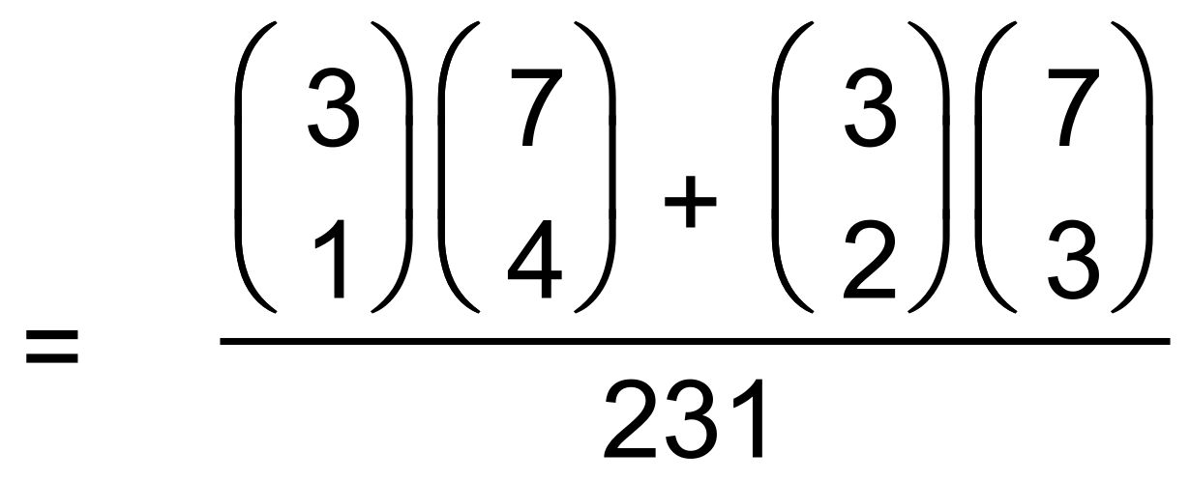 ✓

= 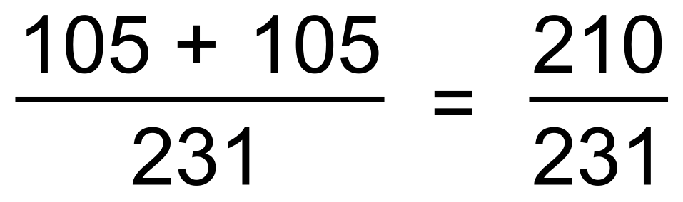 ✓ [10]

20. (a) (i) 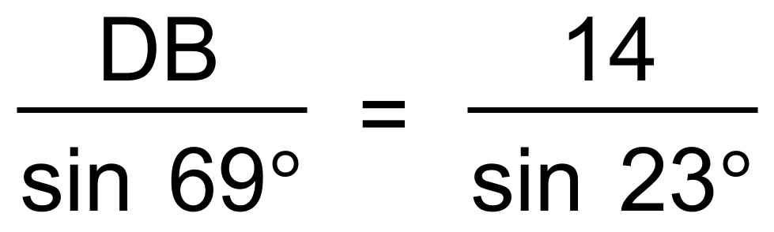 ✓

∴ DB = 33 m ✓

(ii)  ✓

∴ ∠ABD = 19.84° ✓

(b) 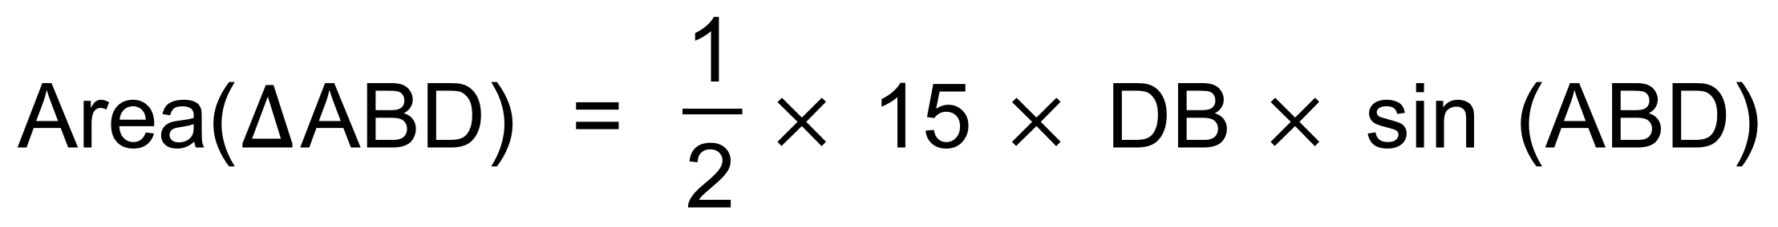 ✓

= 85.16 m2 ✓

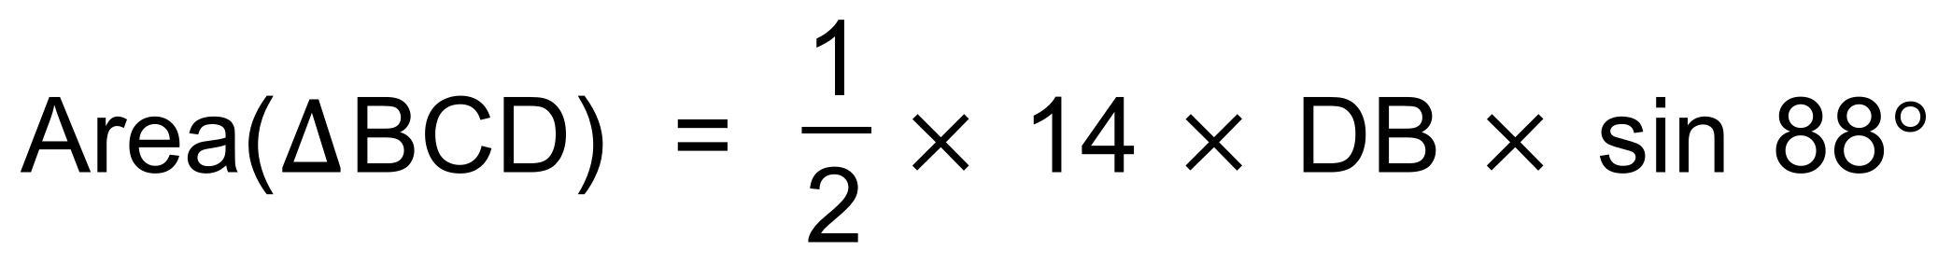 ✓

= 234.01 m2 ✓

∴ Total area = 319.17 m2 ✓ [7]

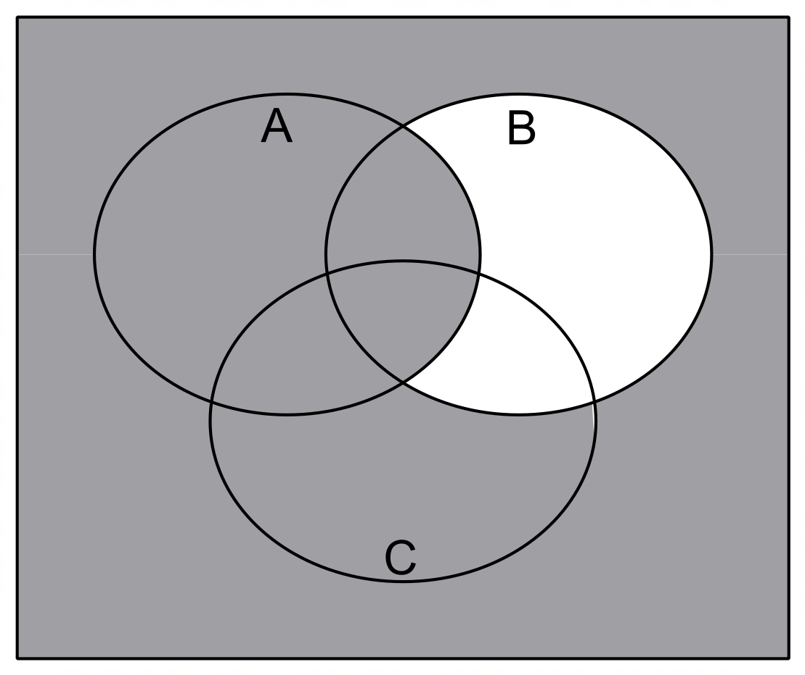21. (a) (i)

✓✓

(ii)

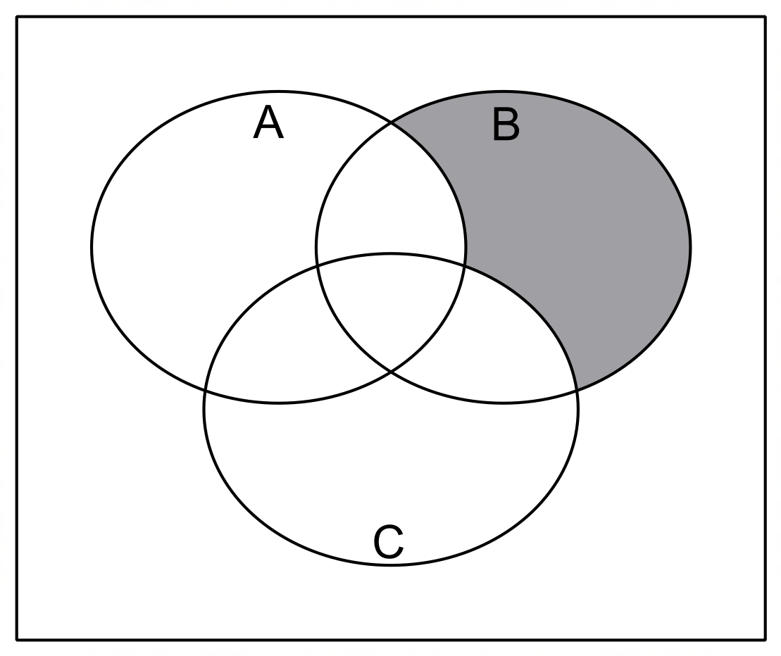

✓✓

(b) E′ ∩ (D ∪ F) ✓✓ [6]

22. (a) P(L1) = 0.7, P(L2) = 0.35, P(L2|L1) = 0.35 and P(L3) = 0.4

Since P(L2) = P(L2|L1) = 0.35 ✓

then independent events. ✓

(b) (i) P(all three) = P(L1) x P(L2) x P(L3)

= 0.7 x 0.35 x 0.4 = 0.098 ✓✓

(ii) P(L1 ∪ L2) = P(L1) + P(L2) − P(L1 ∩ L2)

= 0.7 + 0.35 − 0.7 x 0.35 = 0.805 ✓✓

(iii) P((L1 ∪ L2 ∪ L3)′|L1′)

= P(L2′ ∪ L3′) ✓

= 0.65 + 0.6 − 0.65 x 0.6 = 0.86 ✓ [8]

23. (a) (i) 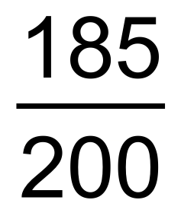 ✓

(ii) 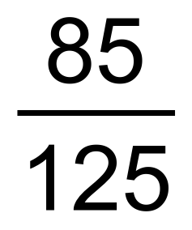 ✓✓

(b) 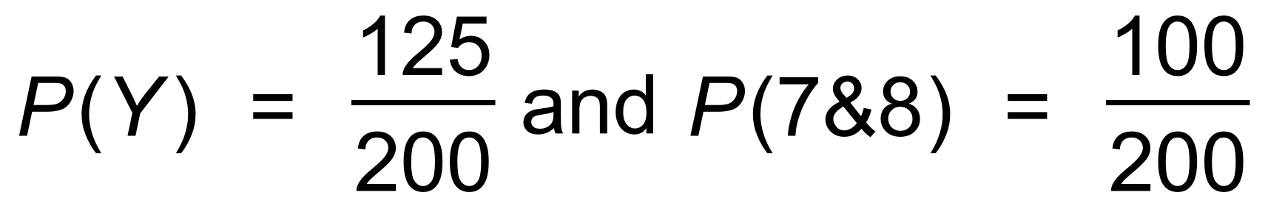

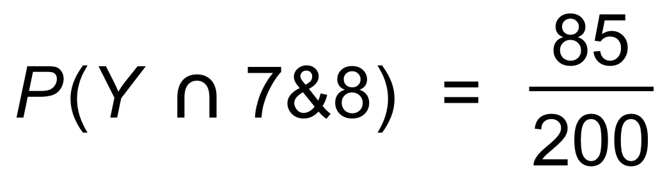 ✓

Since P(Y) x P(7&8) ≠ P(Y ∩ 7&8) then not independent. ✓ [5]